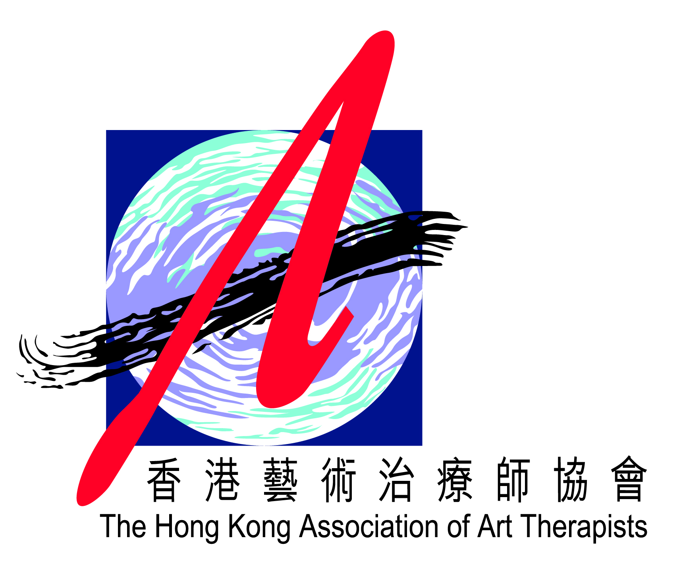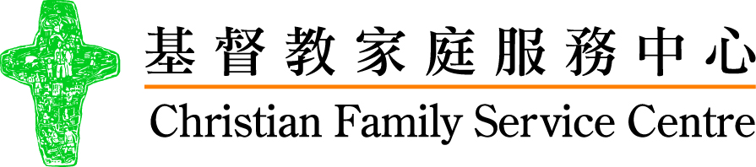

Organizer:



**Registration Form**

|  |  |  |  |  |  |  |  |  |
| --- | --- | --- | --- | --- | --- | --- | --- | --- |
| 1. **PERSONAL PARTICULARS (Please** ☑ **the appropriate)** | | | | | | | | |
| Title: ❒ Prof. ❒ Dr. ❒ Mr. ❒ Ms. | | | | | | | | |
| Surname: |  | | First Name: | | | | |  |
| Organization/ Institution: | |  | Post: | | | |  | |
| Mailing Address: |  | | | | | | | |
| Tel.: |  | | | Fax: | |  | | |
| Email: |  | | | |  | | | |
|  |  | | | |  | | | |

1. **REGISTRATION FEES (Please** 🗹 **the appropriate)**

|  |  |  |  |  |  |
| --- | --- | --- | --- | --- | --- |
| **Topic of the Conference and Workshops** | | | **Registration Fees** | | |
| **Full Price** | **Early-Bird Price** | **Package Price** |
| **After**  **1/9/2016** | **Before**  **1/9/2016** | |
| **🞏 (1). Pre- Conference Workshop: Mentalisation “Level one” Training By Dr. Neil Springham (26-27 Oct 2016)** | | | **🞏$4,000** | | **Package1**  **🞏$5,200**  **(1)+(2)**  **Package2**  **🞏$4,400**  **(2)+(3)**  **Package3**  **🞏$5,600**  **(1)+(3)**  **Package4**  **🞏$6,650**  **(1)+(2)+(3)** |
| **🞏 (2) Conference** **(28-29 Oct 2016) AND Conference Parallel Workshops (29 Oct 2016)** | | | **🞏$3,000** | **🞏$2,500** |
| **Please select one topic (1 or 2) for each workshop** | | |
| **Workshops**  **(A)** | (1) Using Art to Bridge the “Wall of Fear” | (2) Using Strengths Based Art Facilitation to Open the Window into the Adolescent’s Internal World |
| **Workshops**  **(B)** | (1) Therapeutic Empathy in Art Therapy: A Pathway towards Healing and Wholeness for Adolescent Females who Self-injure | (2) Art Therapy and Body Image |
| **Workshops**  **(C)** | (1) Creative Arts for Patients at E.A.S.Y. | (2) Using Art Therapy on Strengthening Attachment and Family Resilience between Cancer Patients and Their Children in Treatment Stage. |
| **🞏 (3) Post- Conference Workshop:** **Working with Adolescents: Exploring Metaphors in Existential Art TherapyBy Prof. Ming Fu WU (30-31 Oct 2016)** | | | **🞏HK$3,000** | |
| **Total (HK$):** | | |  | | |

|  |  |  |  |
| --- | --- | --- | --- |
| 1. **PAYMENT METHOD**   **🞏 Cheque payment (Please make a crossed cheque payable to “Christian Family Service Centre”)** | | | |
| Bank： |  | Cheque No： |  |
| Please return the registration form with a crossed cheque to the following address.  **🞏 Transfer**  **Direct transfer to “ Christian Family Service Centre” , HSBC 030-001580-001 or Bank of East Asia 531-40-06926-5** and fax 2706-5776 or mail the bank slip and the form to the following address.  **Address:** Centre for Adolescent Mental Health Prevention and Intervention  G/F, Hong Lam House, Tsui Lam Estate, Tseung Kwan O, Kowloon. | | | |
| **Notices：**   * You can fax: 2706 5776/E-mail: ym@cfsc.org.hk the completed registration form to reserve the seat and send the crossed cheque / bank slip later. Please write your name and phone no. at the back of the cheque / bank slip. * You will be notified by e-mail to confirm your application after completing the application procedure. * Receipts will be issued on the day of the Conference/Workshop. * Unless the application is not accepted or the Conference/Workshop is cancelled, the payment will not be refunded or transferred. * If the Typhoon Signal no. 8 or above, or the Black Rainstorm Warning Signal is hoisted, the conference /Workshop will be cancelled. Details of postponement will be announced later. | | | |
| 1. **ENQUIRY** | | | |
| Tel: (852) 2706 5262  Fax: (852) 2706 5776  Email: [ym@cfsc.org.hk](mailto:ym@cfsc.org.hk)  **Signature of the Applicant：___________________ Date：__________________** | | | |

